Scrutinise Central —User Test

Stage 1 test checklist
- [ ] Create a top-level Community; you appear as OWNER #Done
- [ ] Add a branch (child Community) from the tree; add a sub-branch beneath that; rename one #Done – but UI isn’t clear, very basic. Needs a proper hierarchy and buttons
- [ ] Assign a manager to a branch #Done
- [ ] Generate an invite code #Done
- [ ] Joining account is shown the invite screen (name, rules, points summary) and cannot join without passing through it #Done
- 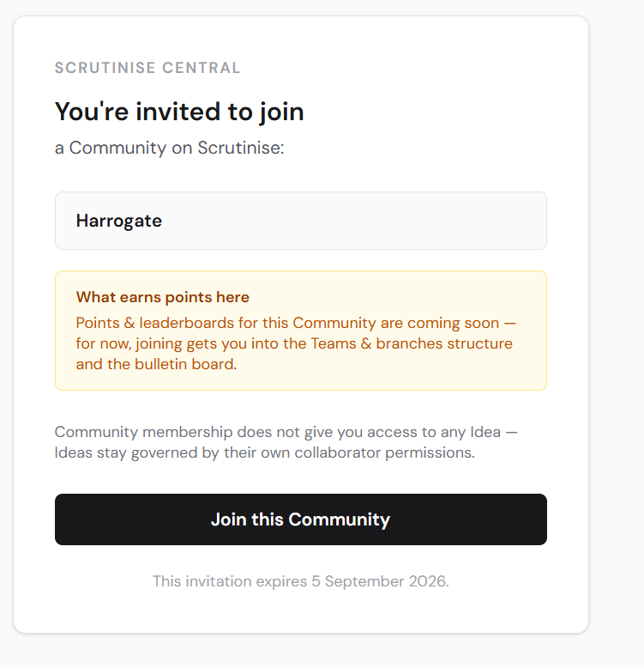
- If invited to join a branch ,how can you move to another branch?
- [ ] Joined account appears as MEMBER; correct role badges shown #Done
- [ ] Post a thread with a category tag; reply from the second account; upvote and downvote #can’t see how to upvote and downvote
- 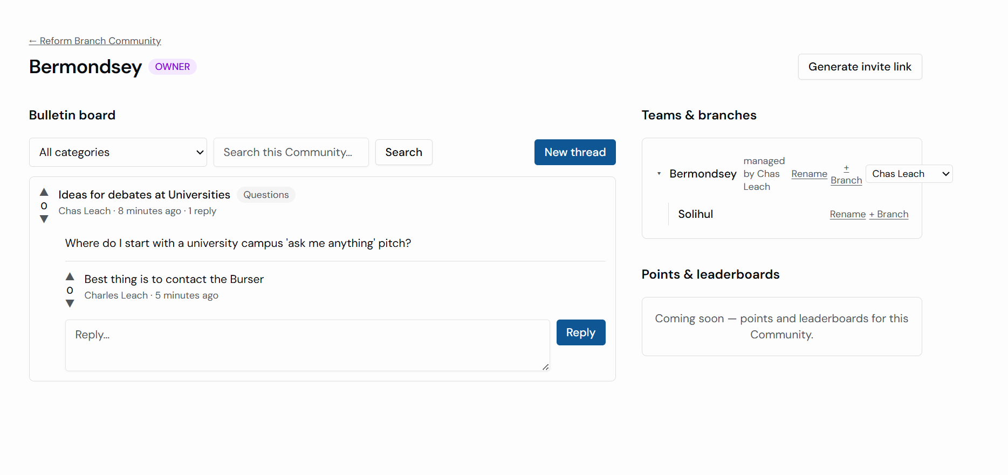
- 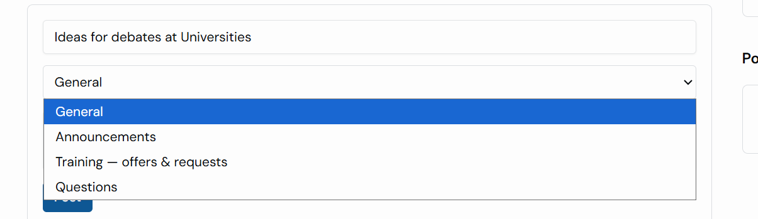
- I don’t want “Announcements”, main categories should be Canvassing, Building Members, Public Debates, Training, Running Councils, Questions.
I also want the Nav bar entry to say “Central” rather than “Communities” which are the things you create in Central.
- 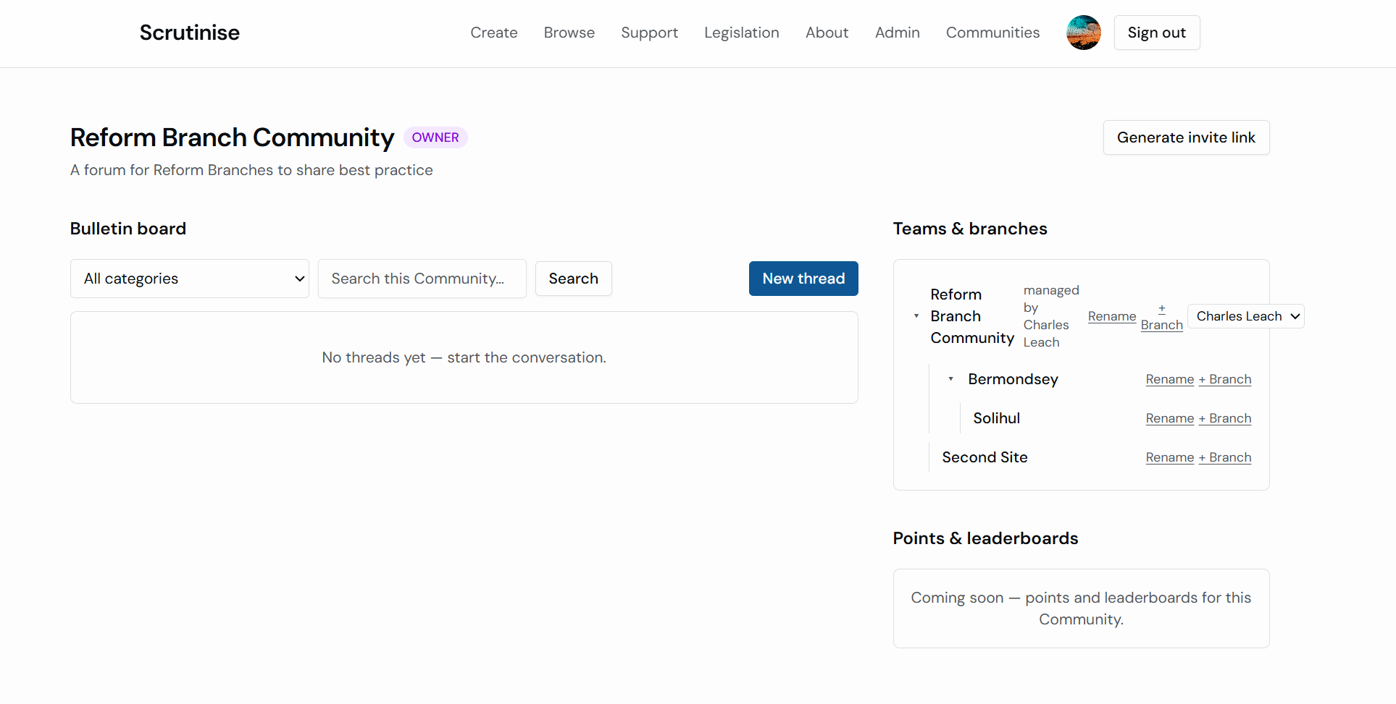
- [ ] Content posted in one Community is invisible from another Community and from logged-out/public view #Done, only appears in the branch view. #Done
- [ ] Branch-scoped board shows only that branch's posts #Done
- [ ] Keyword search returns matches from this Community only #Can’t see how to do a keyword search
- [ ] Dashboard shows "My Communities and teams" with Community and Idea-team cards side by side – #possibly, the communities teams are all there, when I tried to invite by email address it didn’t find the user, only by first name. I created an idea team but it doesn’t show up on the dashboard for “My Communities and Teams” Also the dashboard should show/hide the ideas if more than 3 of them, so the teams/communities is obvious in the dashboard, same for more than 4 teams/communities.
- 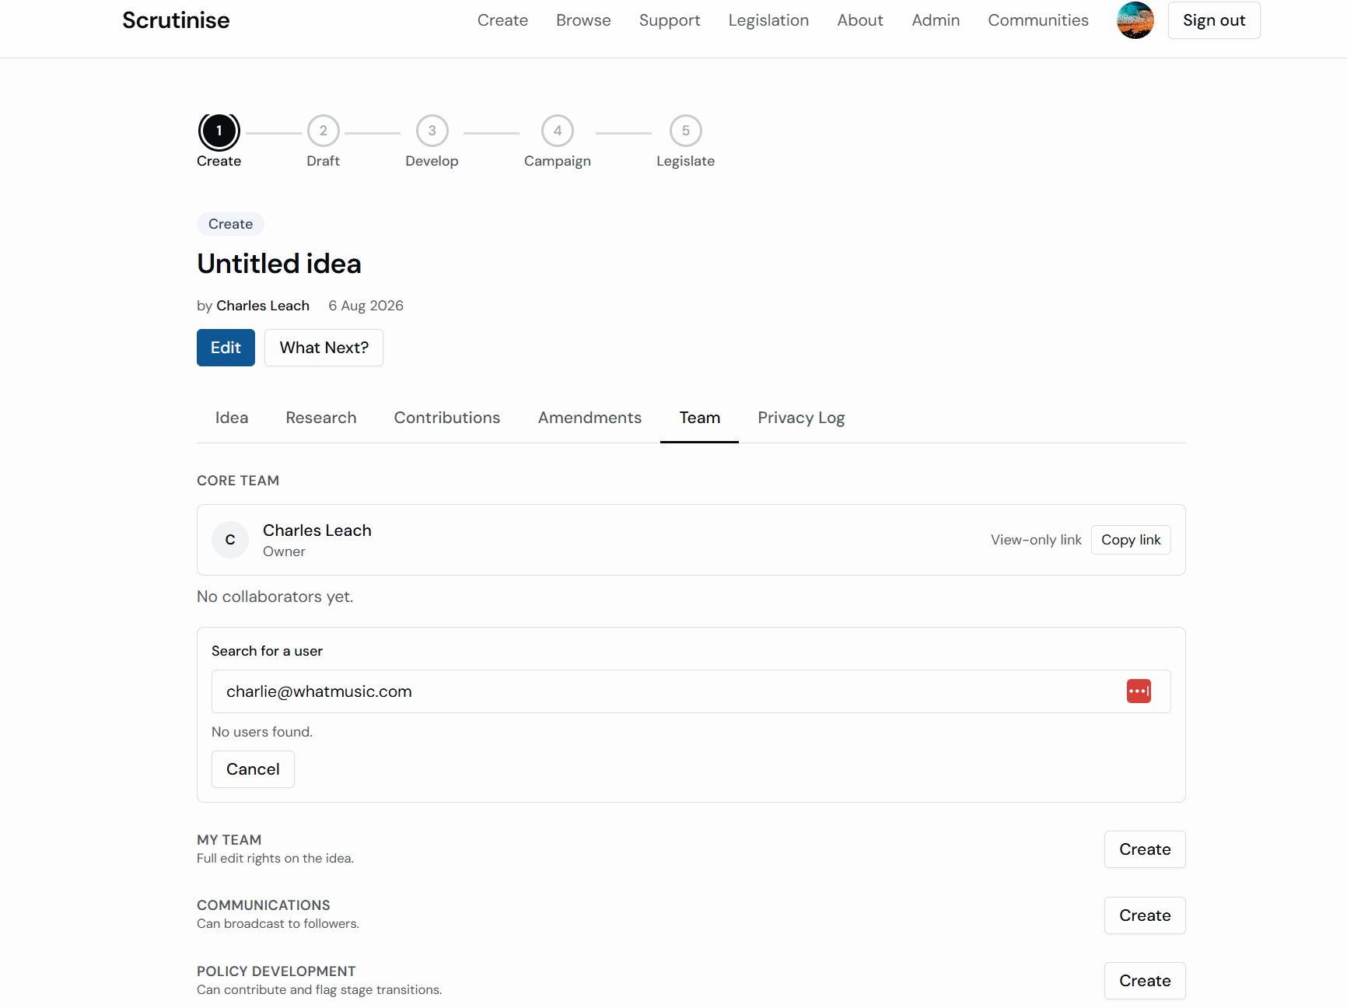 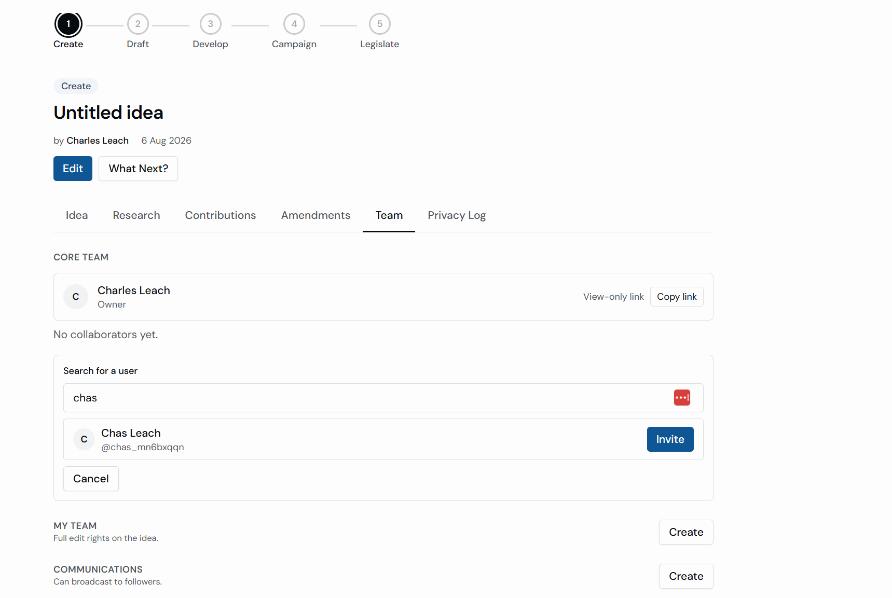”
- [ ] Feed shows recent posts/replies; "Upcoming" shows an intentional empty state, not an error #Done
- [ ] Points & leaderboards region visible as a labelled stub #DONE

Explicitly NOT in Stage 1
- Structured training marketplace — workaround: seed a "Training — offers & requests" bulletin category at launch so the behaviour can start as ordinary posts –# This workaround is the priority
- Events and .ics calendar downloads
- Points earning, leaderboards (stub only)
- Abuse-reporting workflow, admin analytics, semantic search
- 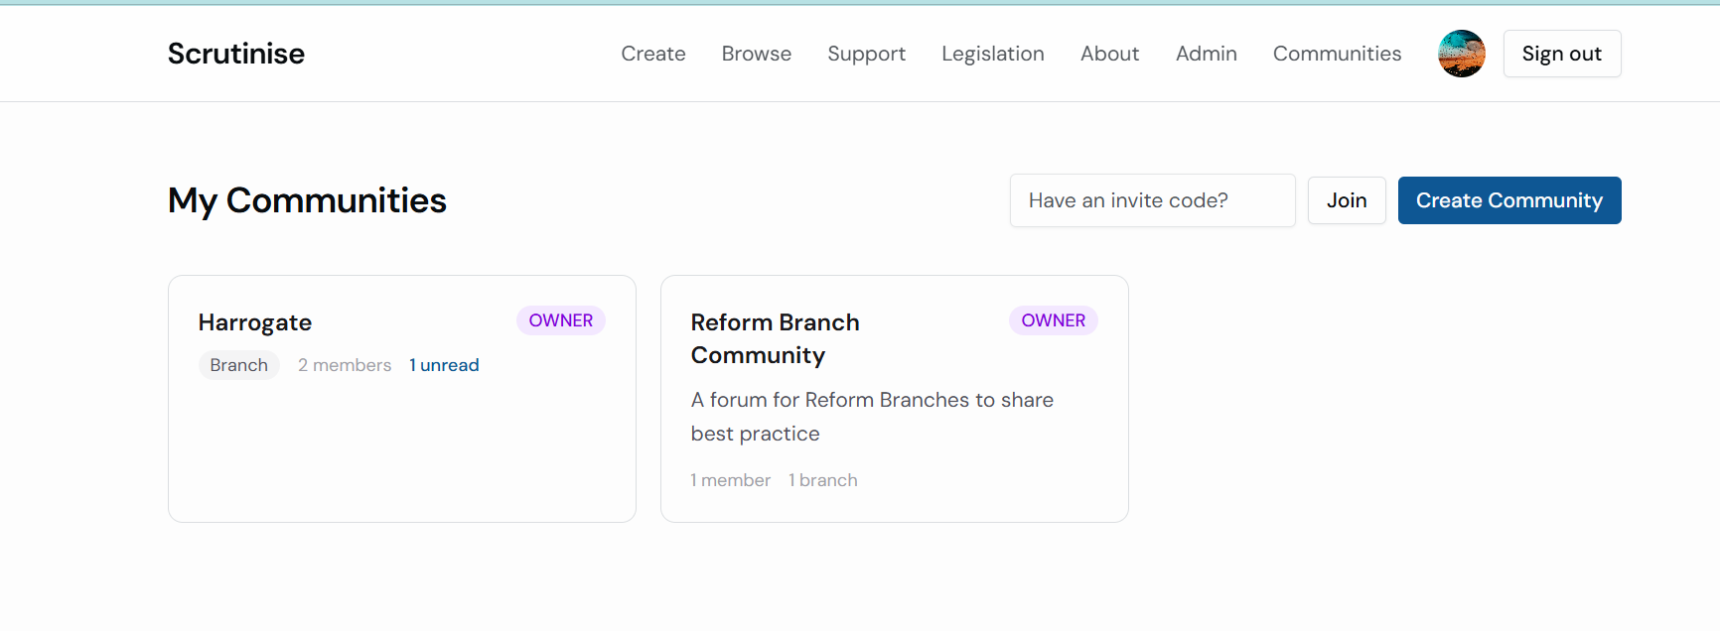
- Anything that’s posted should have the option of posting to your branch or the whole community.
If you get an invite from the community level how do you join a branch?

